Assignment 3

Aim:To simulate a cloud scenario using CloudSim and run a scheduling algorithm that is not present in CloudSim.

**Theory:**

Basics of Scheduling In computers, Scheduling is a process of arranging the submitted jobs/task into a very specific sequence of execution. It is an essential characteristic of any software operating environment, which is handled by a very special program known as a scheduler.

Scheduler’s main objective is to keep the underlined hardware resources to be used effectively as well as efficient. In general, the scheduler may prefer to have any of the following scheduling approaches: Space-shared: In this, the requested resources are allocated dedicatedly to the requesting workload for execution and will be released only on completion. Space-shared is also known as a batch process scheduling

Time-shared: In this, the requested resources would be shared among more than one workload(task). The sharing is done based on time-sliced allocation where each workload is allocated with a required resource for a defined time(e.g., 200 milliseconds). The virtual machine(s) are powered by a physical server host machine (i.e.) hardware.

1.Virtual Machine to Host Machine

2.Tasks to Virtual Machines

**Scheduling in Cloudsim**

The Cloudsim simulation toolkit framework has effectively addressed the Scheduling scenario and implemented it as a set of the programmable class hierarchies with parent class as:

1. VmScheduler

2. CloudletScheduler

**Cloudsim Virtual Machine Scheduling**

The **VmScheduler** is an abstract class that defines and implements the policy used to share processing power among virtual machines running on a specified host. The hierarchy of the cloudsim virtual machine scheduler classes is as:

**Cloudsim Virtual Machine Scheduler Class Hierarchy**

VmSchedulerTimeShared

VmSchedulerSpaceShared

VmSchedulerTimeSharedOverSubscription

**Cloudsim Cloudlet Scheduling**

The ―CloudletScheduler” is an abstract class that defines the basic skeleton to implement the policy to be used for cloudlet scheduling to be performed by a virtual machine. The hierarchy of the cloudsim Cloudlet scheduler classes is as

**Cloudlet Scheduler Class Hierarchy**

CloudletSchedulerSpaceShared

CloudletSchedulerTimeShared

CloudletSchedulerDynamicWorkload

**Simulating the Cloud Environment**

CloudSim is a simulation tool that allows cloud developers to test the performance of their provisioning policies in a repeatable and controllable environment, free of cost. It helps tune the bottlenecks before real-world deployment. It is a simulator; hence, it doesn‘t run any actual software. It can be defined as running a model of an environment in a model of hardware‘, where technology-specific details are abstracted. CloudSim is a library for the simulation of cloud scenarios.

**The main components of the CloudSim framework**

**Regions:** It models geographical regions in which cloud service providers allocate resources to their customers. In cloud analysis, there are six regions that correspond to six continents in the world.

**Data centers:** It models the infrastructure services provided by various cloud service providers. It encapsulates a set of computing hosts or servers that are either heterogeneous or homogeneous in nature, based on their hardware configurations.

**Cloudlet:** It specifies the set of user requests. It contains the application ID, name of the user base that is the originator to which the responses have to be routed back, as well as the size of the request execution commands, and input and output files

**How to use CloudSim in Eclipse**

CloudSim is written in Java. The knowledge you need to use CloudSim is basic Java programming and some basics about cloud computing. Knowledge of programming IDEs such as Eclipse or NetBeans is also helpful.It is a library and, hence, CloudSim does not have to be installed. Normally, you can unpack the downloaded package in any directory, add it to the Java classpath and it is ready to be used. Please verify whether Java is available on your system.

**To use CloudSim in Eclipse:**

1Download CloudSim 3.0.3.zip file from <https://github.com/Cloudslab/cloudsim/releases>(assets)

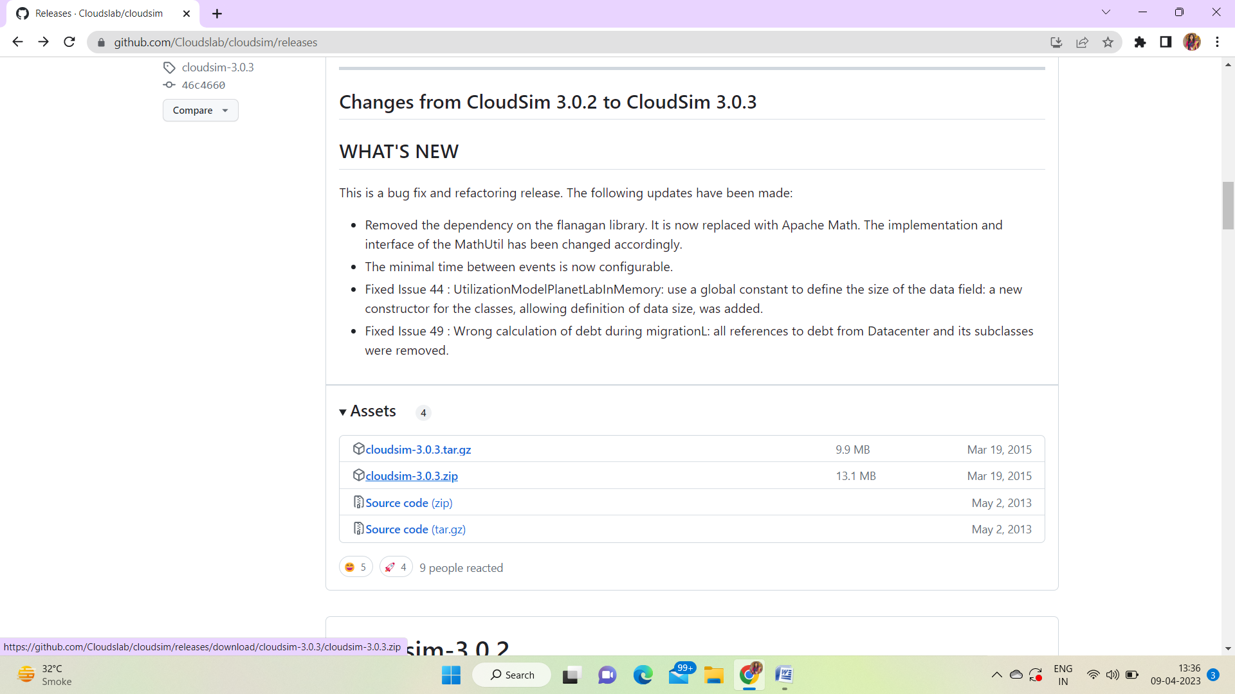

2.Extract the zip file in particular folder

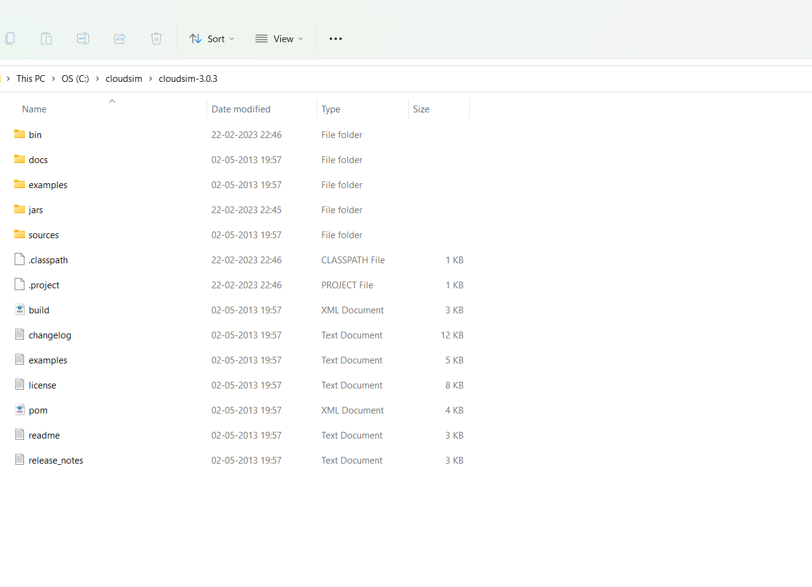

3.Download Common-math jar (<http://www.java2s.com/example/jar/c/download-commonsmath3361jar-file.html>)

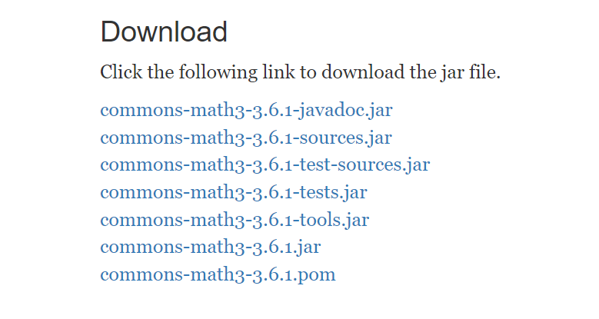

4.Copy common-math.jar file in the same folder created for cloudsim

5.Create a new Java Project: File -> New &

6.Import an unpacked CloudSim project into the new Java Project

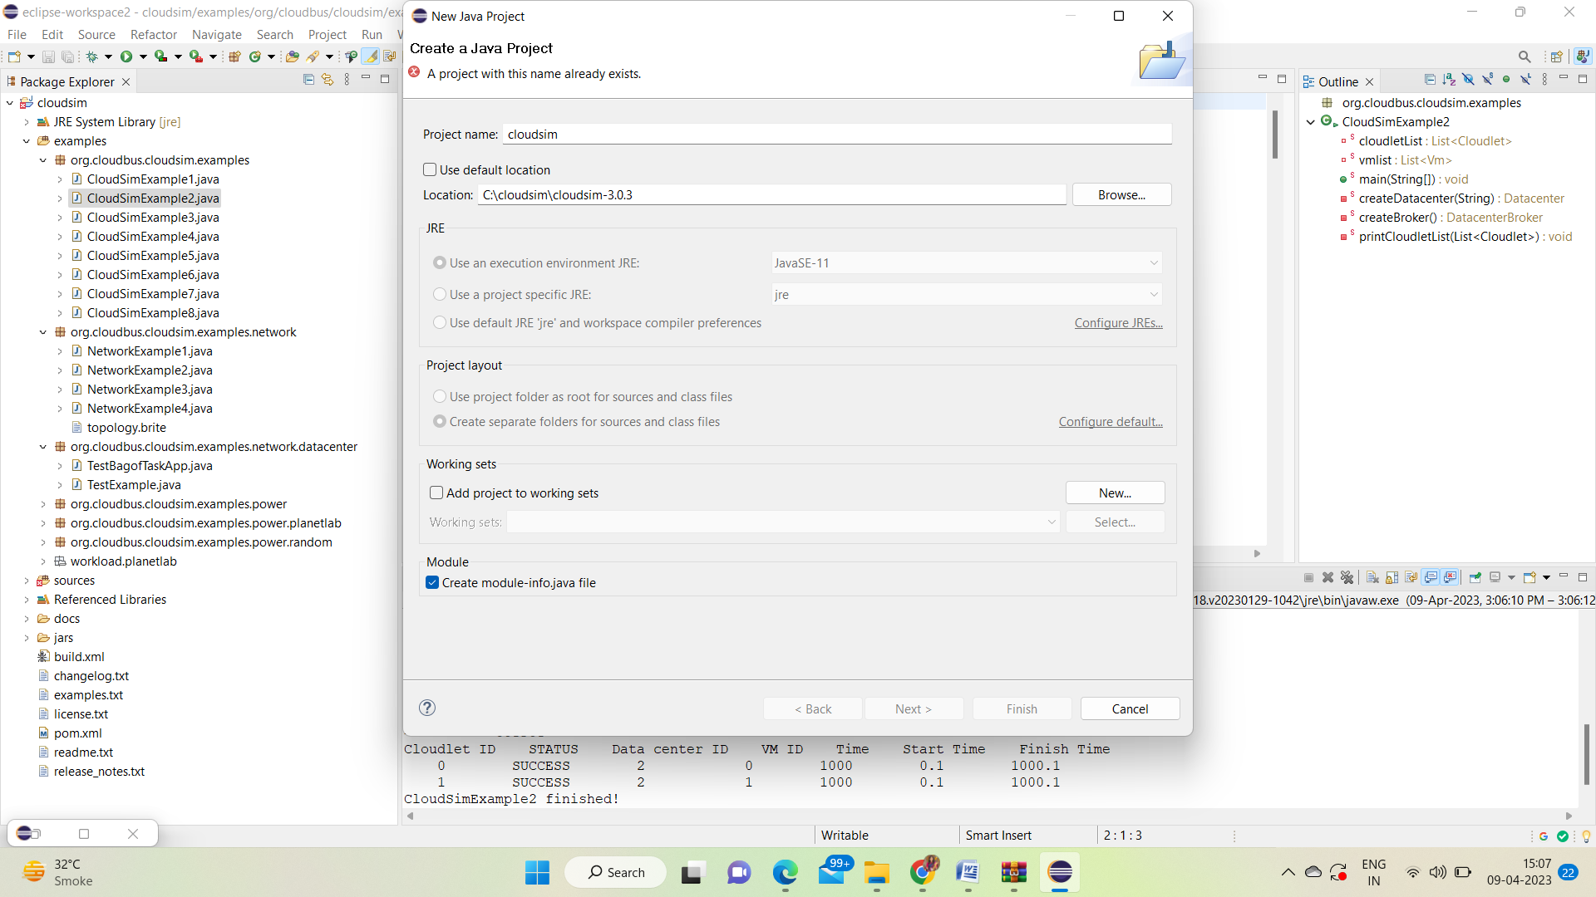

7.Cloudsim scheduling examples (Example1)

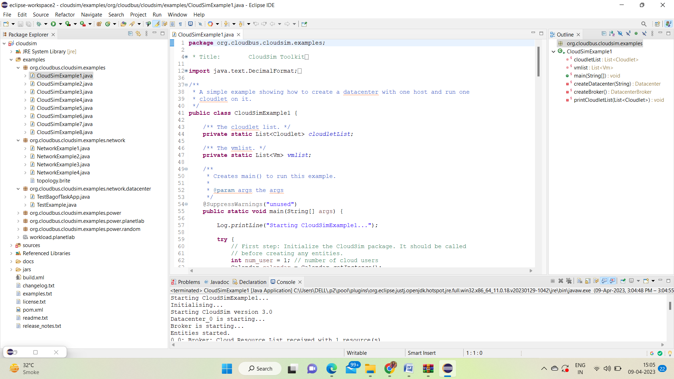

Example2

